Packets & Frames
Packets and frames are small pieces of data that
A packet is a piece of data from Layer 3 (Network Layer) of the OSI model, containing information such as an IP header and payload.
For example, when loading an image from a website, this image is not sent to your computer as a whole, but rather small pieces where it is reconstructed on your computer.
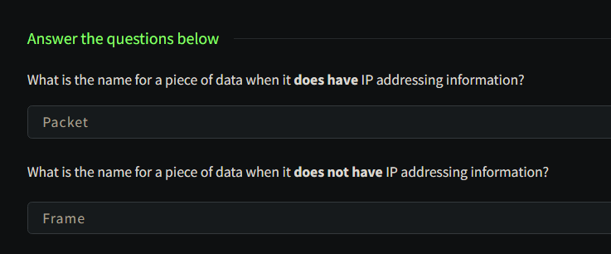
TCP:
TCP (or Transmission Control Protocol for short) is another one of these rules used in networking.

This protocol is very similar to the OSI model that we have previously discussed in room three of this module so far. The TCP/IP protocol consists of four layers and is arguably just a summarised version of the OSI model. These layers are:
- Application
- Transport
- Internet
- Network Interface

One defining feature of TCP is that it is connection-based, which means that TCP must establish a connection between both a client and a device acting as a server before data is sent.
Because of this, TCP guarantees that any data sent will be received on the other end. This process is named the Three-way handshake
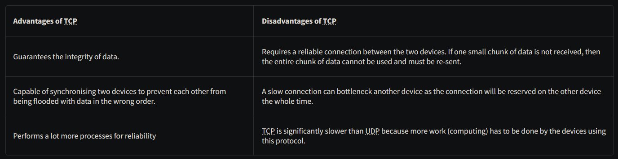
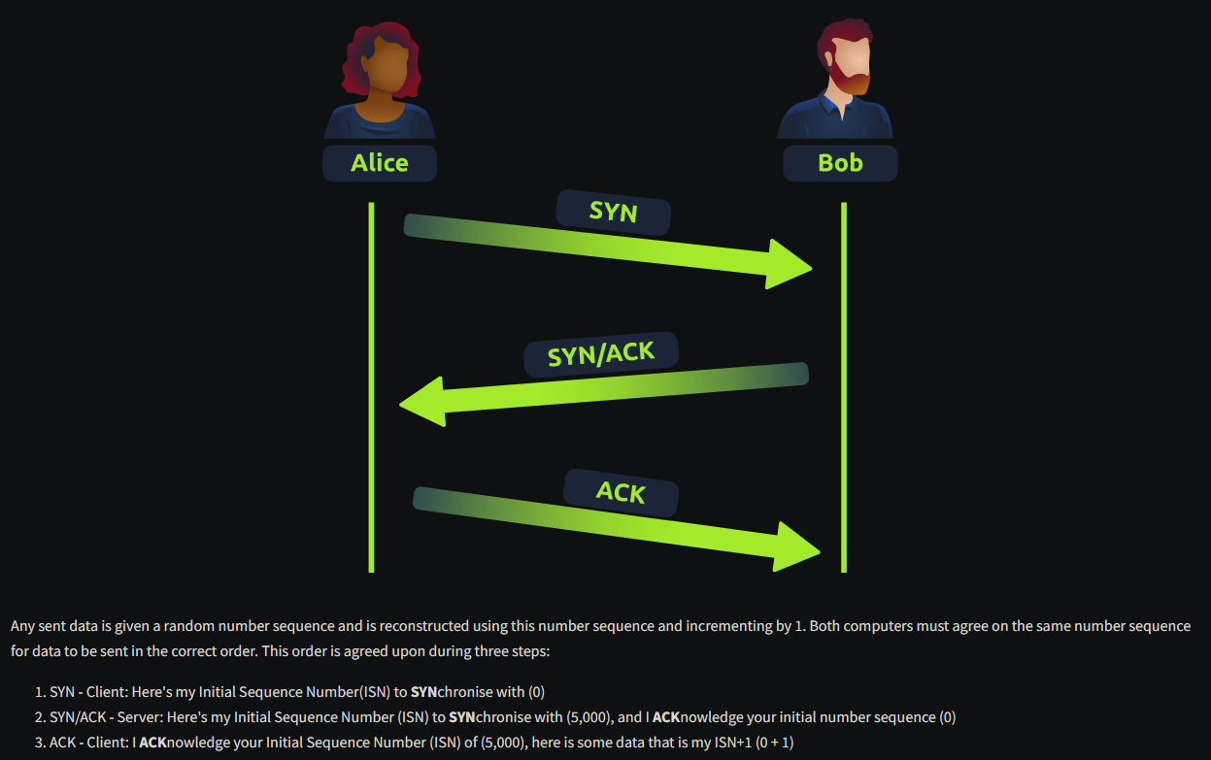
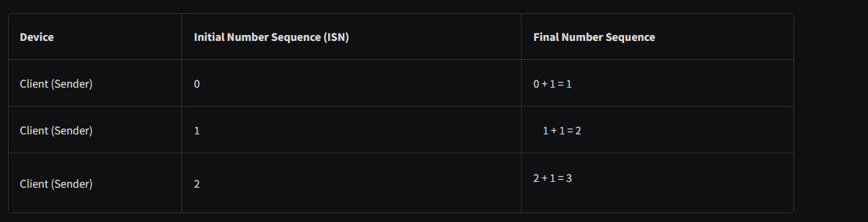
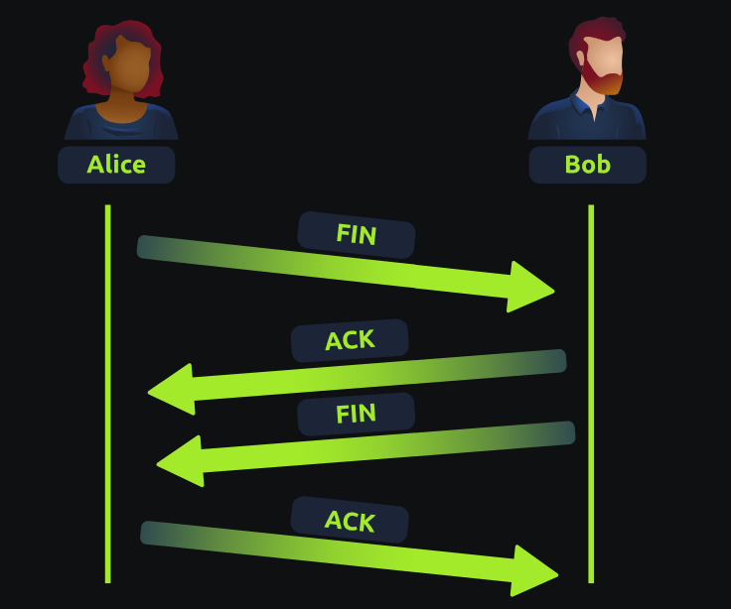
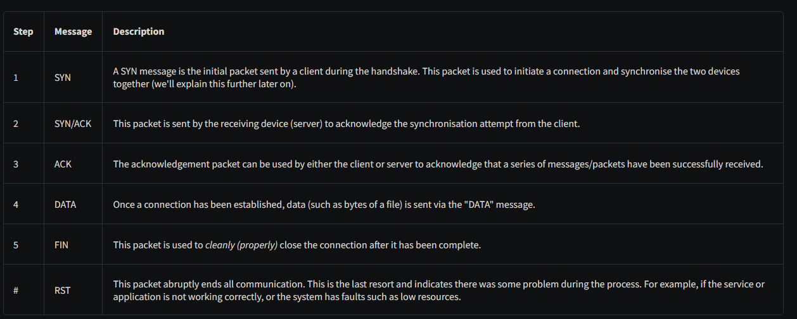
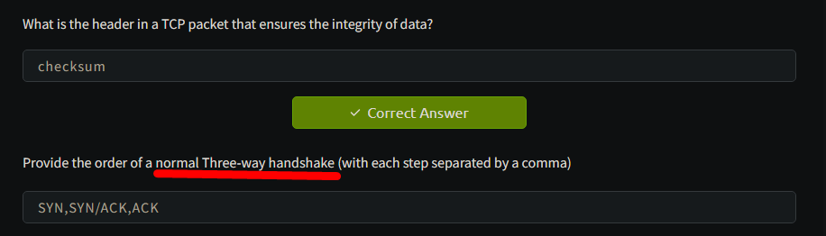

Syn
syn/ack
ack
data
ack
fin/ack
ack

UDP:
The User Datagram Protocol (UDP) is another protocol that is used to communicate data between devices.
Unlike its brother TCP, UDP is a stateless protocol that doesn't require a constant connection between the two devices for data to be sent. For example, the Three-way handshake does not occur, nor is there any synchronisation between the two devices.
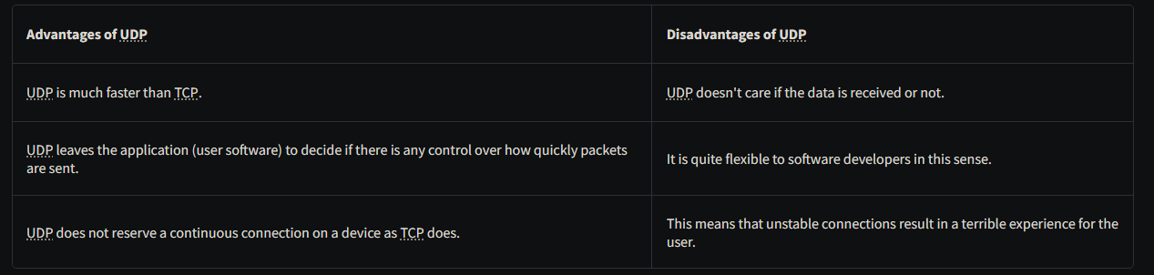
UDP packets are much simpler than TCP packets and have fewer headers. However, both protocols share some standard headers
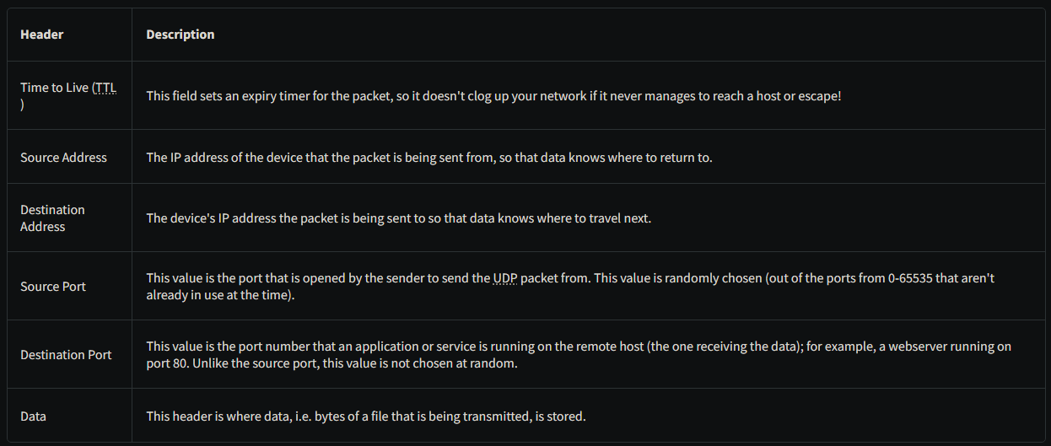
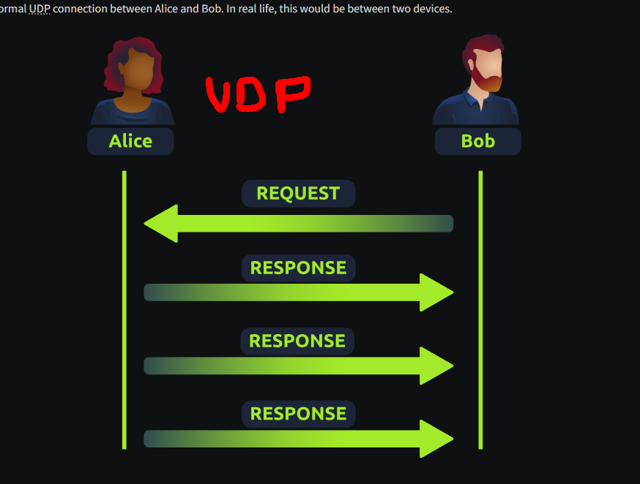
PORTS 101:
ports are an essential point in which data can be exchanged
Networking devices also use ports to enforce strict rules when communicating with one another. When a connection has been established (recalling from the OSI model's room), any data sent or received by a device will be sent through these ports.
In computing, ports are a numerical value between 0 and 65535 (65,535).
software developers can design a web browser such as Google Chrome or Firefox to interpret the data the same way as one another.
This means that all web browsers now share one common rule: data is sent over port 80.

Port | Service | Description
21 | FTP | File Transfer Protocol – used to transfer files between client and server
22 | SSH | Secure Shell – secure remote access to systems
23 | Telnet | Remote access protocol (NOT secure, outdated)
25 | SMTP | Simple Mail Transfer Protocol – used to send emails
53 | DNS | Domain Name System – translates domain names into IP addresses
80 | HTTP | HyperText Transfer Protocol – used for web traffic (not secure)
110 | POP3 | Post Office Protocol v3 – used to receive emails
139 / 445 | SMB | Server Message Block – file and printer sharing in networks
443 | HTTPS | Secure HTTP – encrypted web communication
3389 | RDP | Remote Desktop Protocol – remote control of a computer

